

Lab Task - 03
Only for course Teacher
 |  | Needs Improvement | Developing | Sufficient | Above Average | Total Mark
Allocate mark & Percentage |  | 25% | 50% | 75% | 100%
Clarity
Content Quality
Spelling & Grammar
Organization and Formatting
Total obtained mark
Comments

Semester: Fall 2026
Student Name: Shahriar Salman
Student ID:26010168
Batch: 46 Section: B
Course Code: CSE 124
Course Name: Object Oriented Programming Language Lab
Course Teacher Name: Debabarata Mallick
Designation: Lecturer
Submission Date: 15 / 08/ 2026
Problem:17. Binary Addition
Write a Java program to add two binary numbers.
Input Data:
Input first binary number: 10
Input second binary number: 11
Expected OutputSum of two binary numbers: 101
Solution: 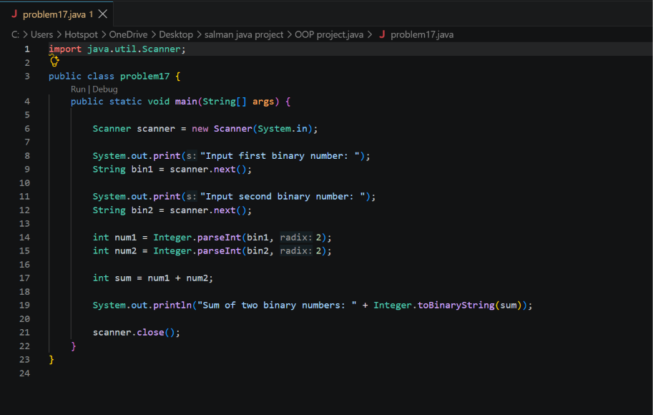
Output:
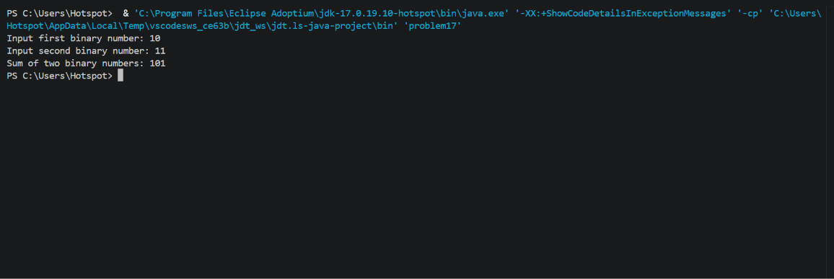Explanation: In this program, I learned how to add two binary numbers. First, the binary numbers are converted into decimal, added together, and then the result is converted back into binary.
Problem :18. Binary Multiplication
Write a Java program to multiply two binary numbers.
Input Data:
Input the first binary number: 10
Input the second binary number: 11
Expected OutputProduct of two binary numbers: 110
Solution:
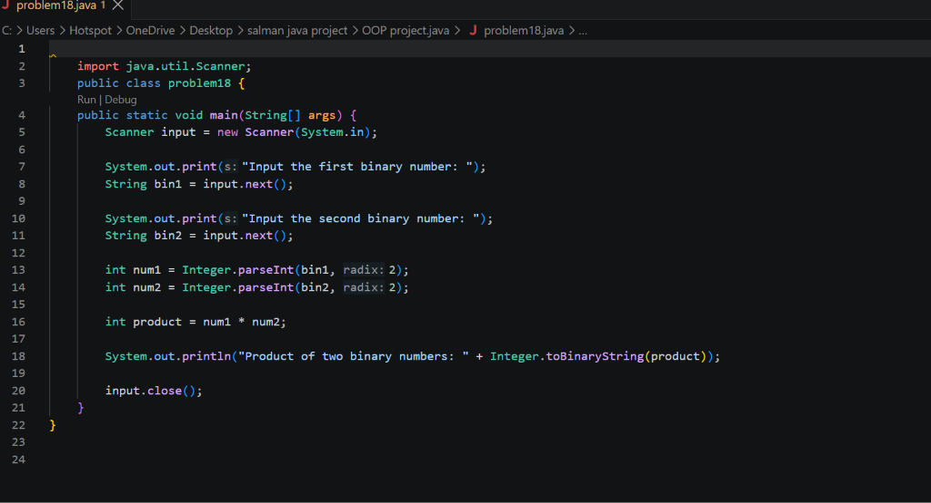
Output:
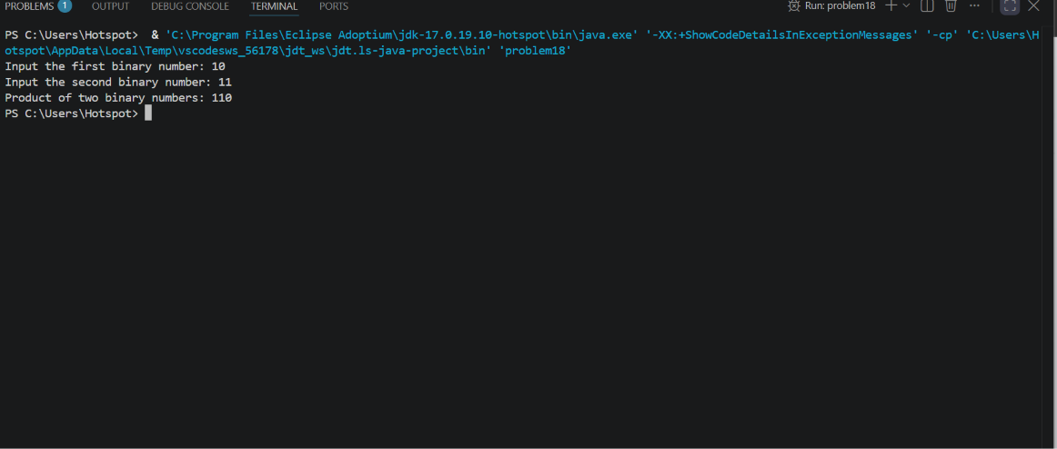
Explanation: In this code, I learned how to multiply two binary numbers. The numbers are first converted into decimal, multiplied, and finally the result is converted into binary.
19. Decimal to Binary Converter
Write a Java program to convert an integer number to a binary number.
Input Data:
Input a Decimal Number : 5
Expected OutputBinary number is: 101
Solution:
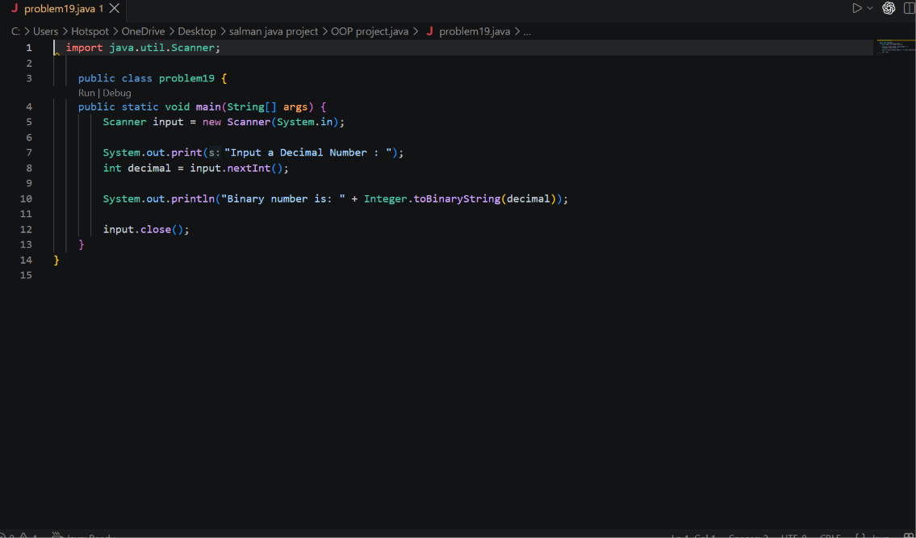
Output:
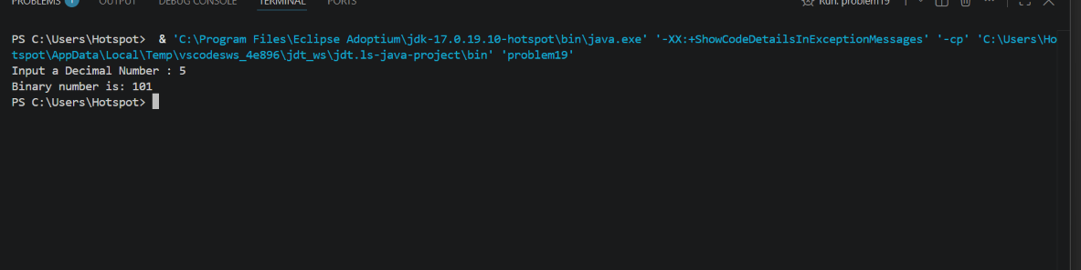
Explanation: In this code, I learned how to convert a decimal number into binary. I used the Integer.toBinaryString() method to get the binary value.

20. Decimal to Hexadecimal Converter
Write a Java program to convert a decimal number to a hexadecimal number.
Input Data:
Input a decimal number: 15
Expected OutputHexadecimal number is : F
Solution:
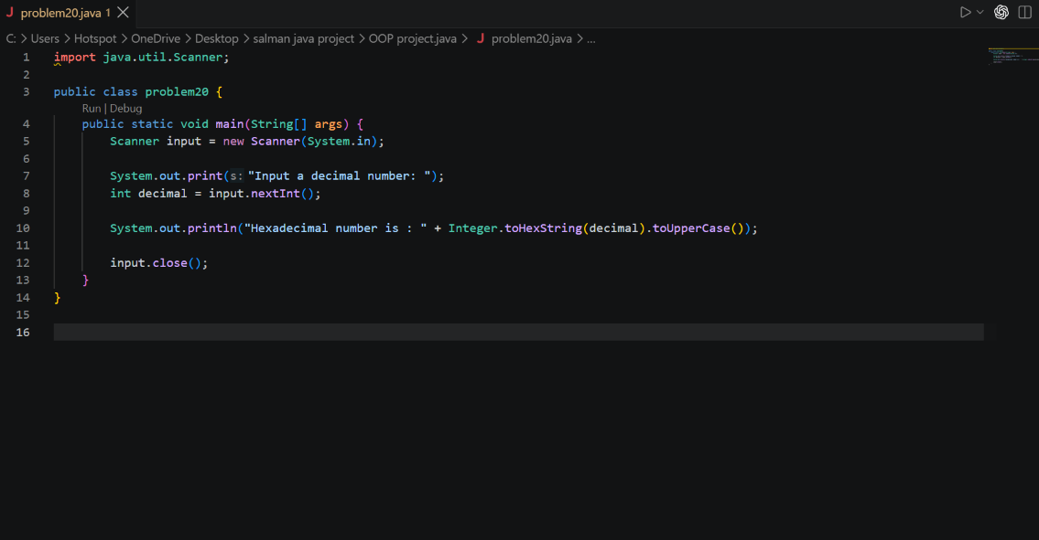
Output:
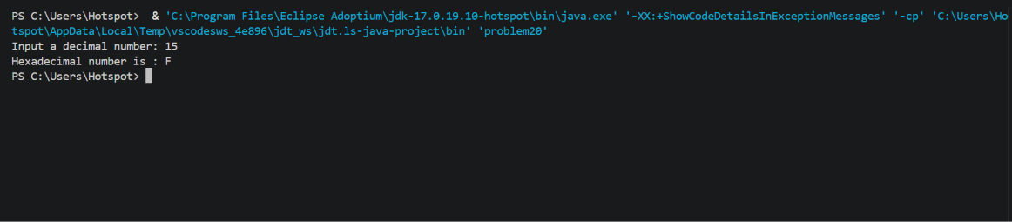

Explanation: In this code, I learned how to convert a decimal number into hexadecimal.Also learned that the Integer.toHexString() method is used for the conversion.

21. Decimal to Octal Converter
Write a Java program to convert a decimal number to an octal number.
Input Data:
Input a Decimal Number: 15
Expected OutputOctal number is: 17
Solution:
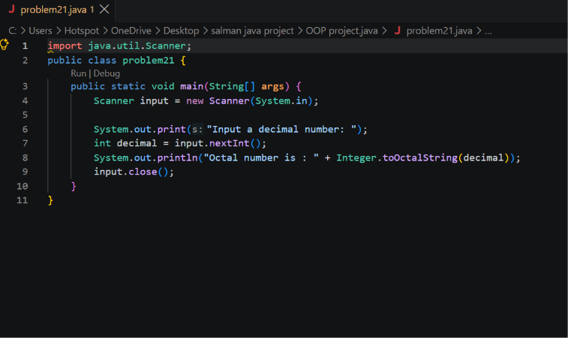
Output:
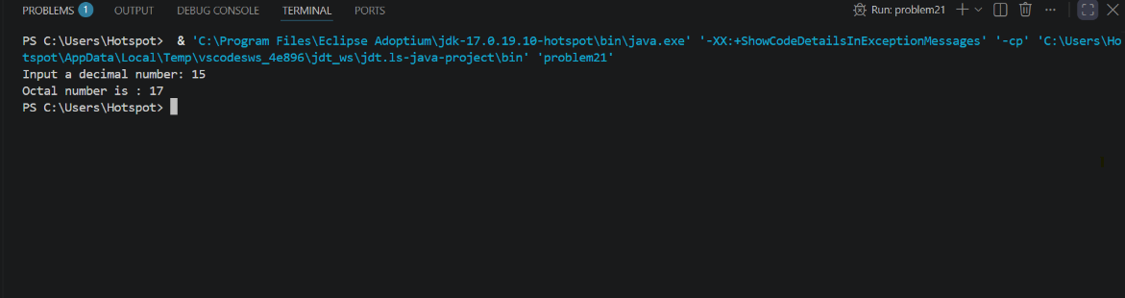
Explanation: In this code, I learned how to convert a decimal number into octal. The Integer.toOctalString() method makes the conversion easier.

22. Binary to Decimal Converter
Write a Java program to convert a binary number to a decimal number.
Input Data:
Input a binary number: 100
Expected OutputDecimal Number: 4
Solution:
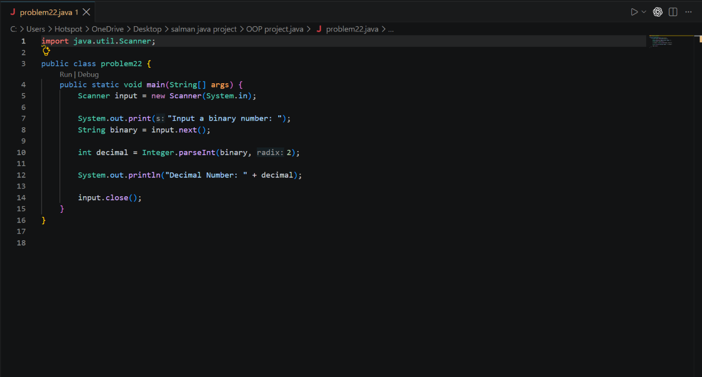
Output:
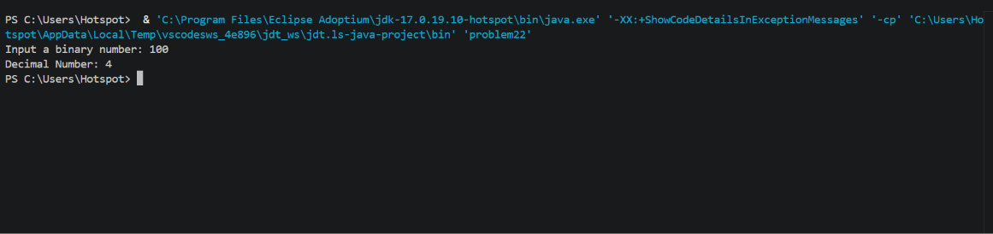
Explanation: In this code, I learned how to convert a binary number into decimal. The Integer.parseInt() method is used with base 2 for this conversion. Which showed the result as 4 of binary number 100 .

23. Binary to Hexadecimal Converter
Write a Java program to convert a binary number to a hexadecimal number.
Input Data:
Input a Binary Number: 1101
Expected OutputHexaDecimal value: D
Solution:
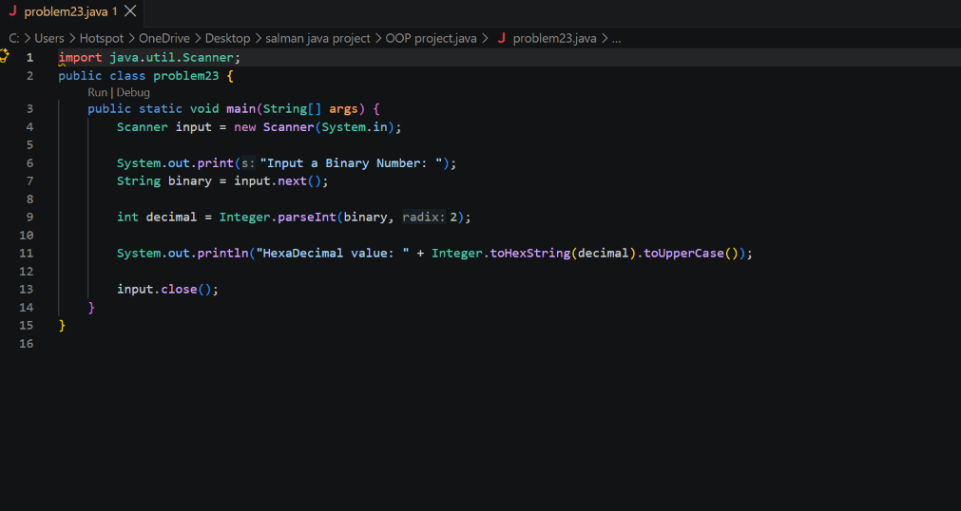
Output:
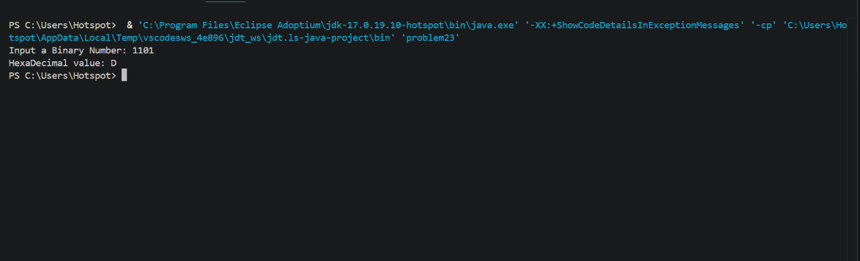
Explanation: In this code, I learned how to convert a binary number into hexadecimal. First, the binary value is changed into decimal, and then it is converted into hexadecimal.

24. Binary to Octal Converter
Write a Java program to convert a binary number to an octal number.
Input Data:
Input a Binary Number: 111
Expected OutputOctal number: 7
Solution:
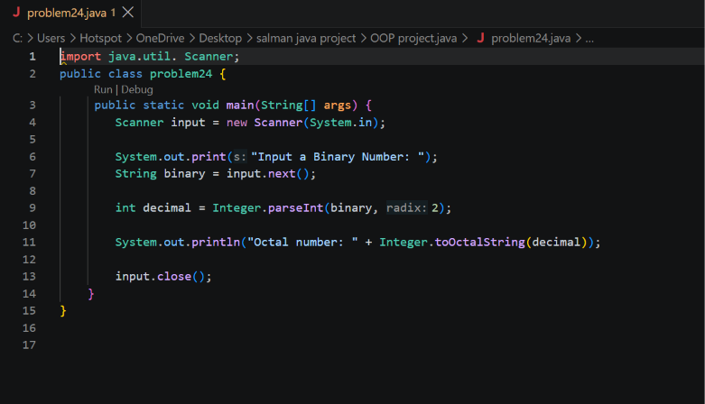
Output:
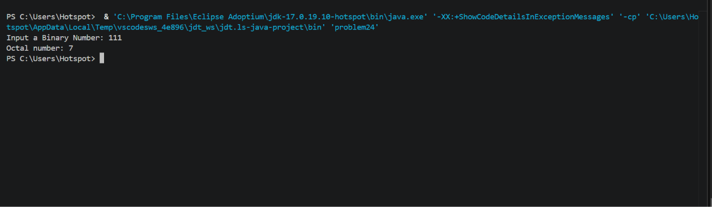
Explanation: In this code, I learned how to convert a binary number into octal. First, the binary number is converted into decimal and then the decimal value is changed into octal.

25. Octal to Decimal Converter
Write a Java program to convert an octal number to a decimal number.
Input Data:
Input any octal number: 10
Expected OutputEquivalent decimal number: 8
Solution:
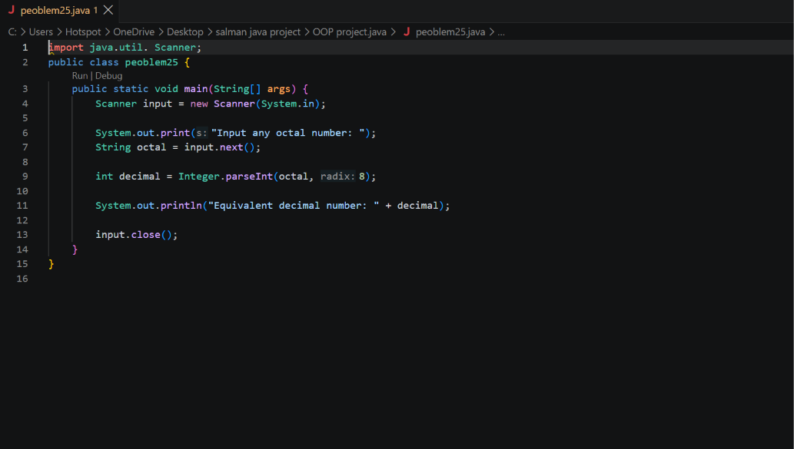
Output:
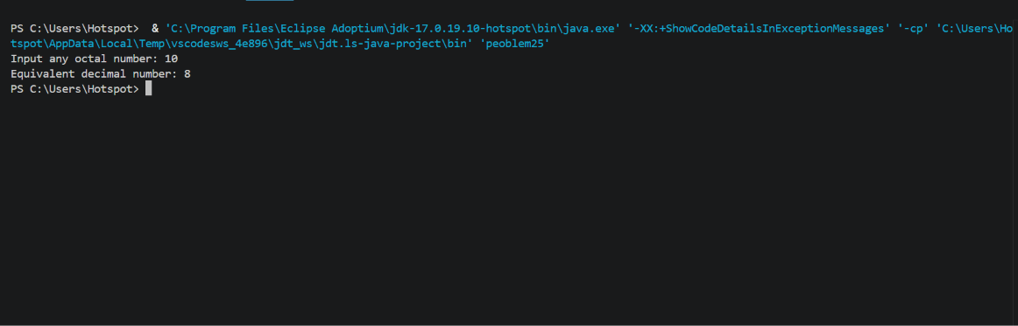
Explanation: In this code, I learned how to convert an octal number into decimal. The Integer.parseInt() method is used with base 8 to get the decimal value. Ultimately the value became 8 in decimal conversion.
26. Octal to Binary Converter
Write a Java program to convert an octal number to a binary number.
Input Data:
Input any octal number: 7
Expected OutputEquivalent binary number: 111
Solution:
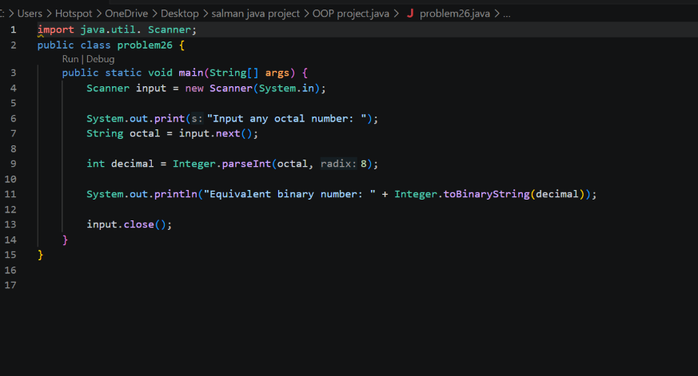
Output:
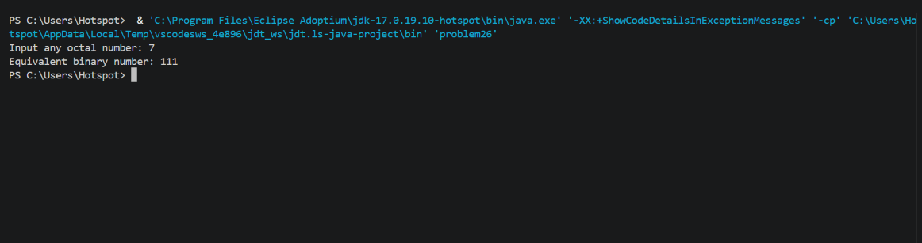
Explanation: In this code, I learned how to convert an octal number into binary. First, the octal number is converted into decimal, and then the decimal value is converted into binary.

27. Octal to Hexadecimal Converter
Write a Java program to convert an octal number to a hexadecimal number.
Input Data:
Input a octal number : 100
Expected OutputEquivalent hexadecimal number: 40
Solution:
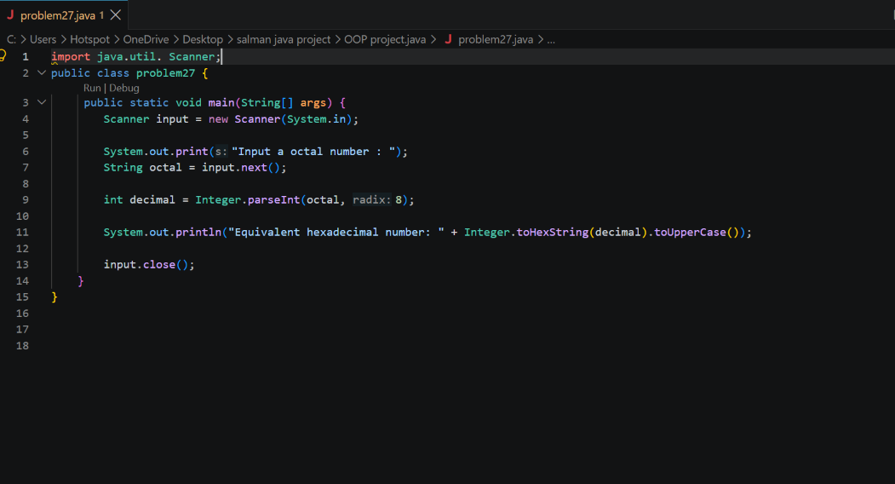
Output:
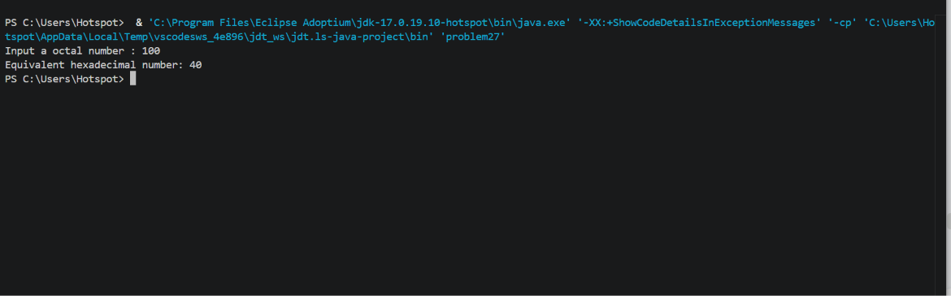
Explanation: In this program, I learned how to convert an octal number into hexadecimal. The octal value is first changed into decimal and then converted into hexadecimal. So basically the conversion among octal values and hexa decimal values .

28. Hexadecimal to Decimal Converter
Write a Java program to convert a hexadecimal value into a decimal number.
Input Data:
Input a hexadecimal number: 25
Expected OutputEquivalent decimal number is: 37
Solution:
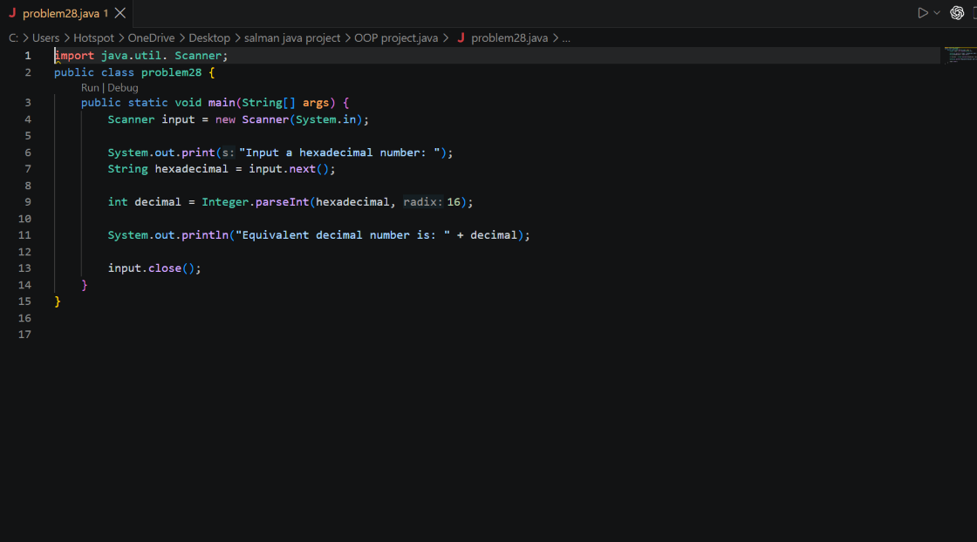
Output:
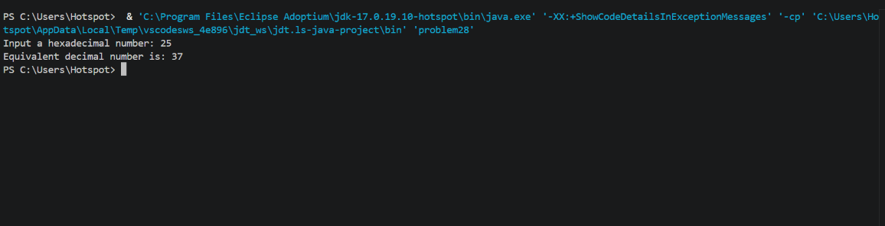
Explanation: In this program, I learned how to convert a hexadecimal number into decimal. The Integer.parseInt() method is used with base 16 to perform the conversion. Mainly learned how Integer .parseInt( ) works .

29. Hexadecimal to Binary Converter
Write a Java program to convert a hexadecimal number into a binary number.
Input Data:
Enter Hexadecimal Number : 37
Expected OutputEquivalent Binary Number is: 110111
Solution:
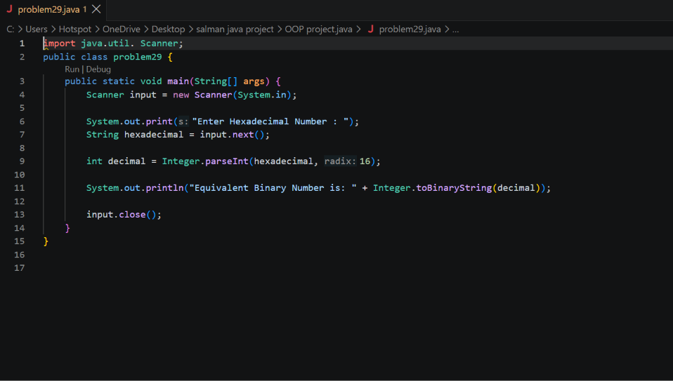
Output:
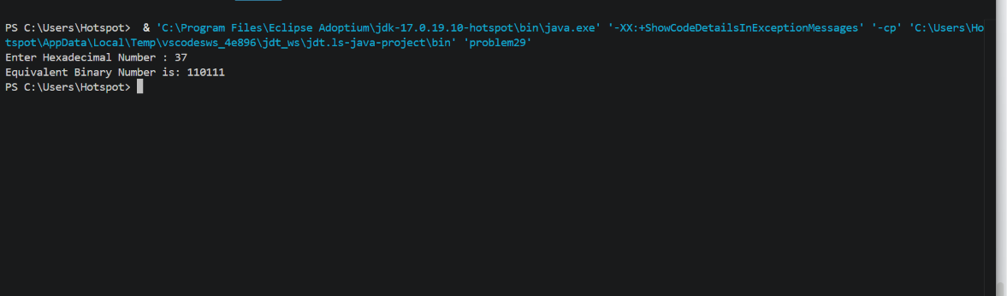
Explanation: In this code, I learned how to convert a hexadecimal number into binary. First, the hexadecimal value is converted into decimal, and then it is changed into binary.

30. Hexadecimal to Octal Converter
Write a Java program to convert a hexadecimal value into an octal number.
Input Data:
Input a hexadecimal number: 40
Expected OutputEquivalent of octal number is: 100
Solution:
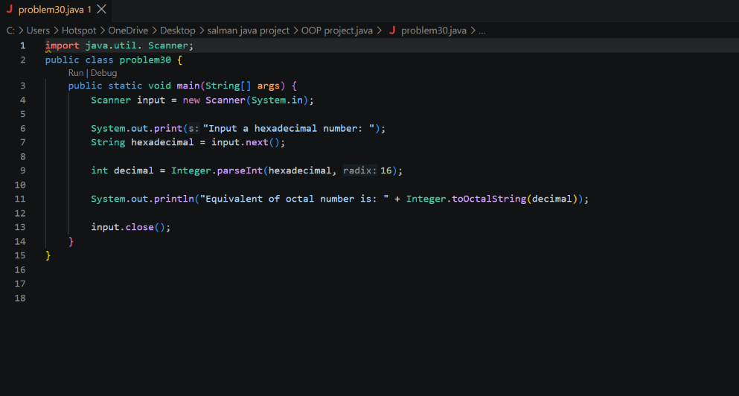
Output:
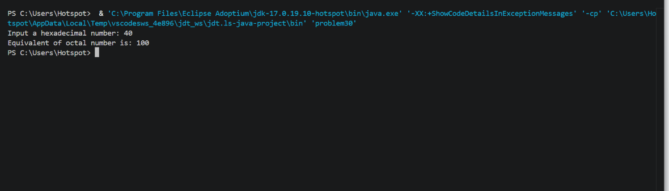
Explanation: In this program, I learned how to convert a hexadecimal number into octal. The hexadecimal value is first converted into decimal and then changed into octal. The answer is 100 in octal number system and 100 is the hexadecimal value .
So solving problems 17 to 30 I learned how the binary addition , multiplication, conversion from one number system to another number system works in java .

